 | Name | DOB | Photo | Category
1 | Yasdeep Rana | 20-08-1999 | 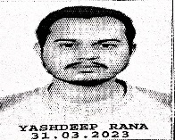 | GENERAL
2 | Chirag Chaudhary | 05-12-2003 |  | OBC
3 | Devesh Gaur | 08-07-2005 | 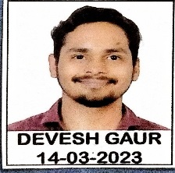 | GENERAL
4 | Shaysha Jha | 26-07-2005 | 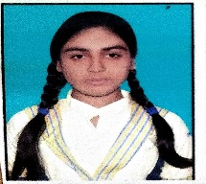 | GENERAL
5 | Rajmani | 25-08-2003 | 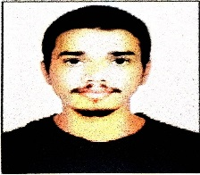 | OBC
6 | Mithilesh Prakash | 01-01-2004 | 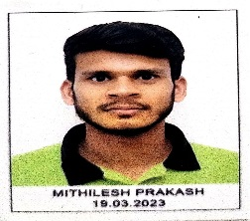 | OBC
7 | Shruti Kumari | 15-10-2004 | 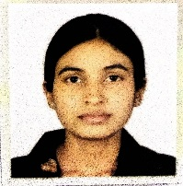 | GENERAL
8 | Aman Kumar Shukla | 16-08-2003 | 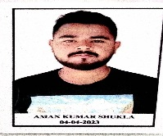 | GENERAL
9 | Peeyush Varshney | 29-12-2003 | 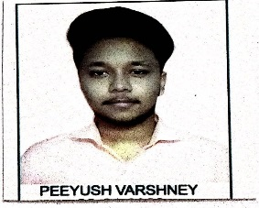 | GENERAL
10 | Manisha Rajpoot | 31-10-2003 |  | GENERAL

