PG category LIST

Sr.No. | Name | DOB | Photo | Category
1 | Jitendra Kumar Bahadur Lekhera | 09-11-1995 | 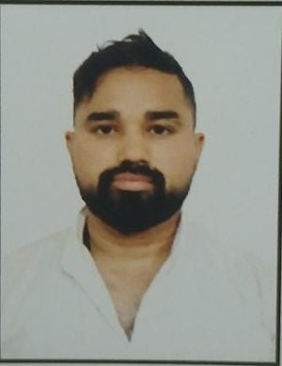 | GENERAL
2 | Punam | 31-12-1989 | 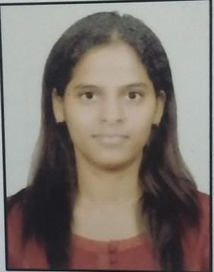 | OBC
3 | Pushpendra Singh Pal | 17-08-1991 | 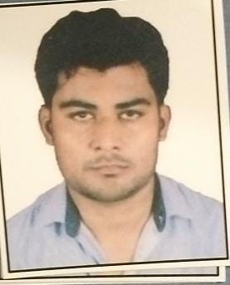 | OBC
4 | Mohd. Faisal Aalam | 19-04-1995 | 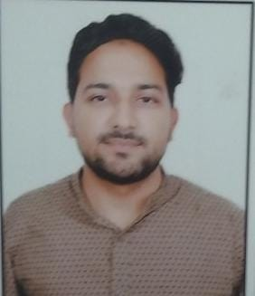 | OBC
5 | Satya Pal Sharma | 10-05-1995 | 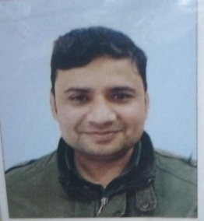 | GENERAL
6 | Arpita Jain | 09-11-1994 | 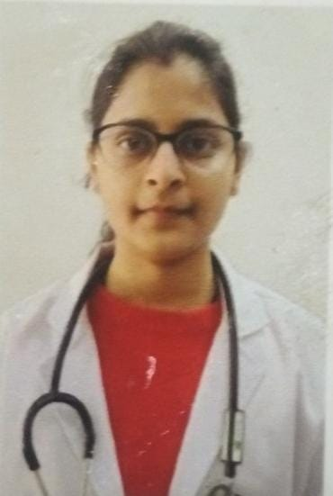 | GENERAL
7 | Aadarsh Srivastav | 02-07-1993 | 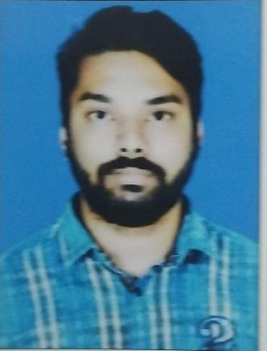 | GENERAL
8 | Hemant Kumar Singh | 03-11-1997 | 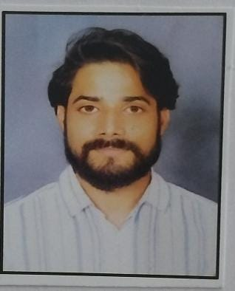 | GENERAL
9 | Udit Maheshwari | 20-04-1997 | 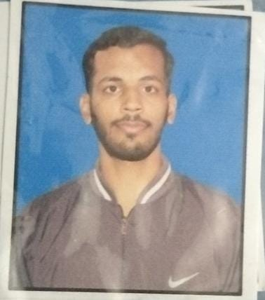 | GENERAL
10 | Pratik Sudhakar Dahake | 11-02-1997 | 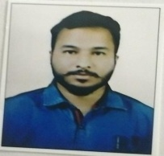 | General
11 | Arati Amarnath Yadav | 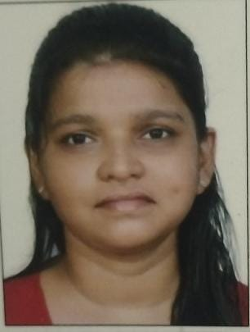  09-06-1995 |  | OBC
12 | Nikhil Katariya | 15-11-1995 | 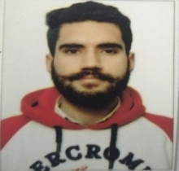 | GENERAL
13 | Huma Khan | 21-10-1995 | 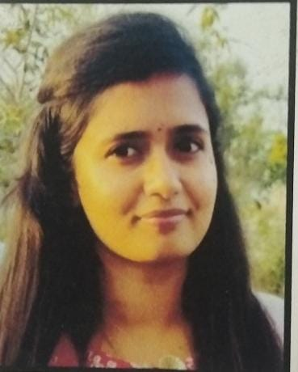 | OBC
14 | Simran | 13-11-1998 | 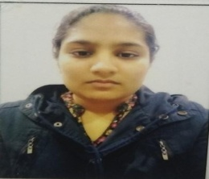 | GENERAL
15 | Kalpana Sen | 13-08-1998 | 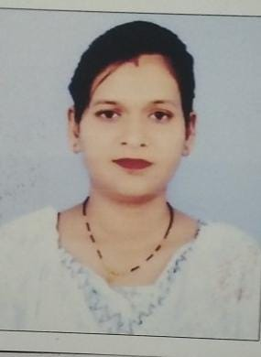 | OBC
16 | Navneet Kumar | 15-05-1993 | 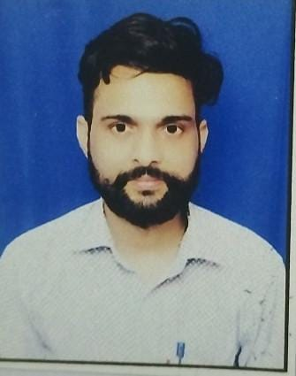 | OBC
17 | Bansode Saurabh Sunil | 17-10-1998 | 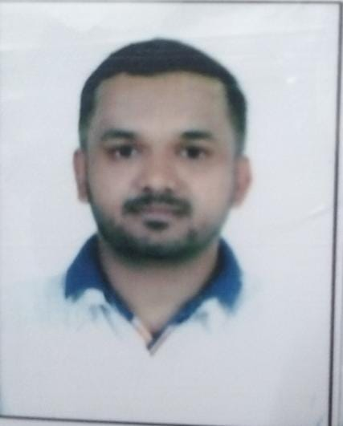 | GENERAL
18 | Agnivrat Parashar | 04-01-1989 | 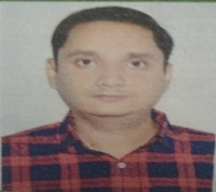 | GENERAL
19 | Sanya | 07-01-1998 | 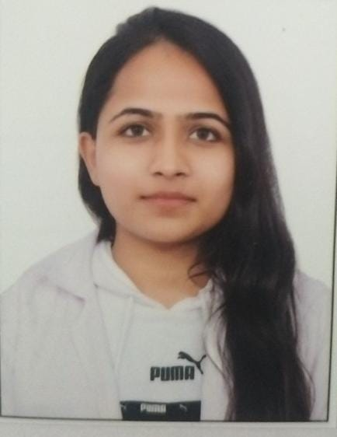 | GENERAL
20 | Kirti | 02-05-1998 | 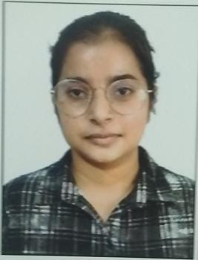 | OBC
21 | Tanu | 02-11-1998 | 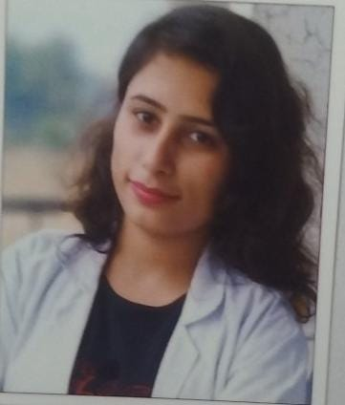 | GENERAL
22 | Aakriti Thapliyal | 22-08-1998 | 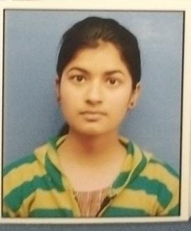 | General
23 | Namita Porwal | 26-03-1988 | 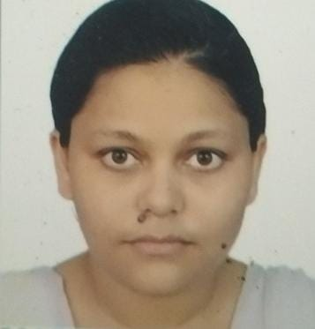 | General
24 | Harsha Gupta | 30-12-1990 | 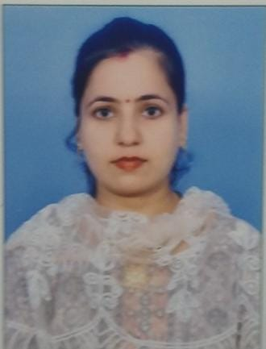 | GENERAL
25 | Nakul Raj | 10-06-1985 | 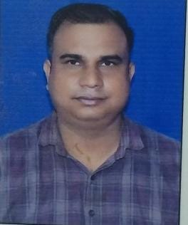 | SC/ST
26 | Shipra Agrahari | 08-07-1991 | 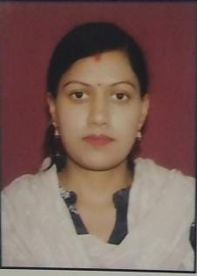 | GENERAL
27 | Ashish Purwar | 01-12-1983 | 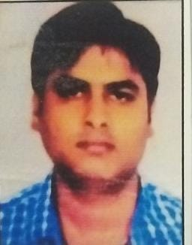 | GENERAL
28 | Jyoti Katiyar | 05-07-1993 | 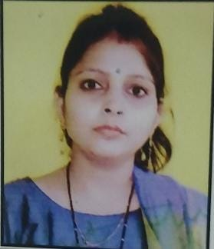 | OBC
29 | Ankit Dev | 13-06-1994 | 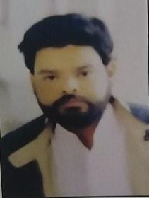 | GENERAL
30 | Rakesh Kumar | 10-03-1986 | 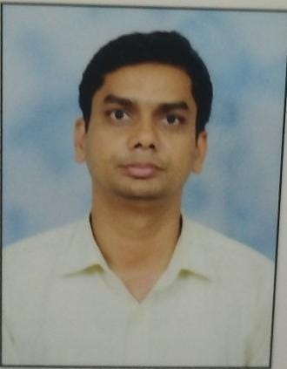 | GENERAL
31 | Amar Deep | 30-08-1995 | 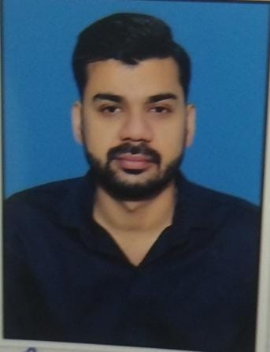 | GENERAL
32 | Avinash Kumar Singh | 24-02-1989 | 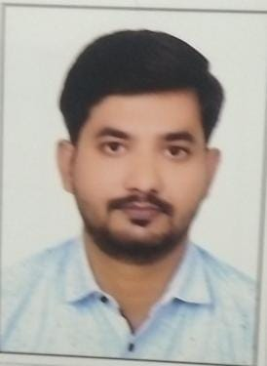 | GENERAL
33 | Pradeep Kaushal | 10-09-1988 | 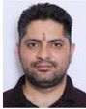 | GENERAL

